Sing, Play, and Dance the Day Away!

Catherine Wilson, Clinician

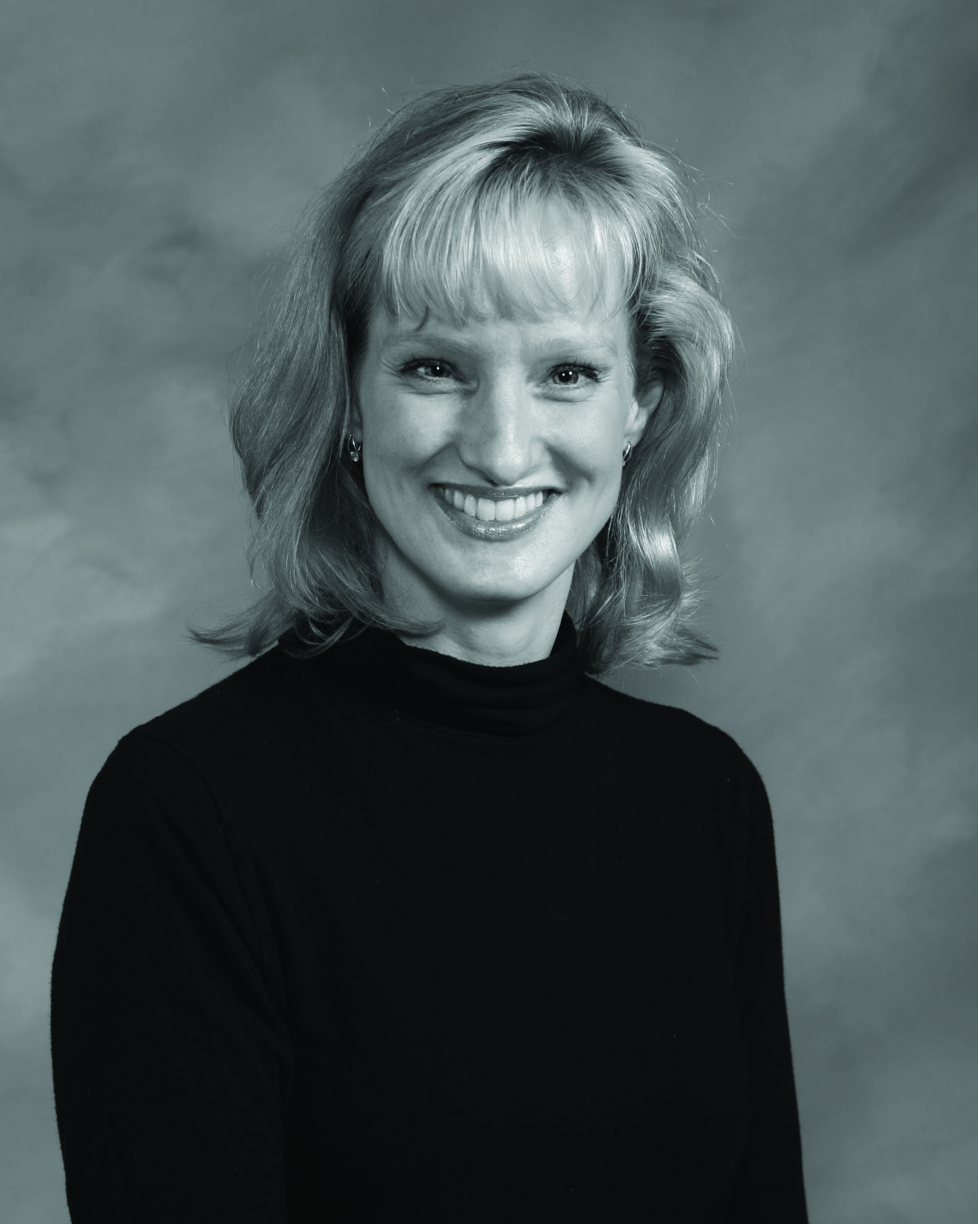

When: Saturday, January 4, 2014, 9:00-4:00 pm
Lunch Break 12:00-1:30 pm
You may bring lunch or eat at one of many local restaurants.

Where: Cumberland University Band Room
Phoenix Plaza Fine Arts Annex
399 South Maple Street, Lebanon, TN 37087

Pre-Registration: Must be received by December 27, 2013
Please see attached form.
Fee: $15.00 (students with ID $5.00)

On-Site Registration:
Saturday, January 4, 2014, 8:15-9:00 am
Band Room, Cumberland University
Fee: $20.00 (students with ID $10.00)

*For more information, contact Dr. Michele Paynter Paise at
mpaise@cumberland.edu
About Catherine Wilson

Catherine (Cat) Wilson is a Ph.D. Candidate in Music Education at the University of Iowa, and an adjunct instructor at Tennessee Technological University. Formerly, she was a high-school vocal music director, elementary music specialist, organist, and pastoral musician. She recently won a fellowship for her research in songwriting, and she was recognized for exceptional research in music education. She was nominated for Hastings Public Schools Teacher of the Year in 2009, and was a Nebraska Elementary Principal’s Award of Excellence recipient in 2006. She co-authored “Singin,’ Sweatin’ and Storytime,” which is published through MENC and Rowman & Littlefield. In addition, Catherine has been an international, national and regional presenter. She holds a bachelor’s degree in Music Education from the University of Louisville in Kentucky and a master’s degree in Music from Colorado State University in Fort Collins. In her spare time, Catherine enjoys distance running, writing and composing. She lives in middle TN with her husband Joe and their 4 musical children.

------------------------------------------------------------------------------------------------------------
Pre-Registration Form
January 4, 2014
Cumberland University Music Education Workshop
*A certificate of completion for in-service credit will be given to all participants

Name___________________________________________________________________
Home Address____________________________________________________________
City___________________________ State_________ Zip ________________________
Home Phone_____________________ Email___________________________________
School__________________________________________________________________
System__________________________________________________________________

Check all that apply:
I am . . . ___ a general music teacher ___ a choral music teacher
___ a classroom teacher ___ a university student
___ a private music teacher ___ other______________

Teaching Assignment Pre-K K 1 2 3 4 5 6 7 8 9 10 11 12 (Please circle)

Make checks payable to Middle Tennessee Association of Kodály Educators

Return this form (Postmarked by Dec 27, 2013) to:

Dr. Michele Paynter Paise
Department of Music
Cumberland University
1 Cumberland Square
Lebanon, TN 37087

